**Assignment – 1**

Install Power BI Desktop and share the final screenshot of the report view page which appears when power desktop starts

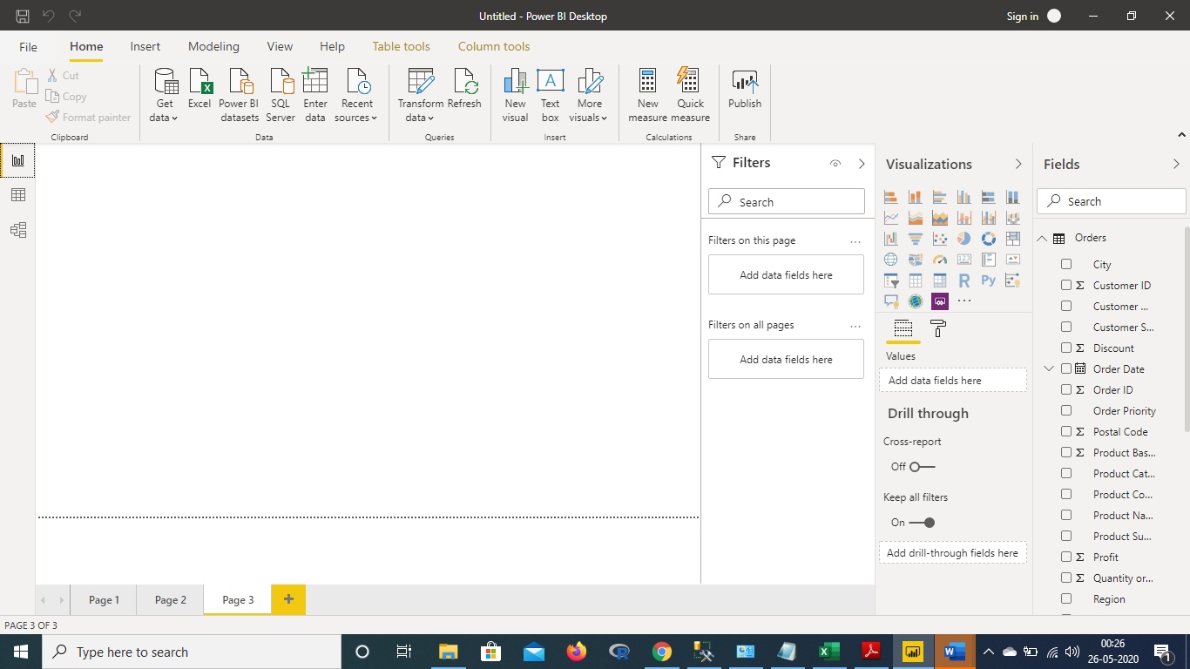

Prepare a document and with the following screenshot –

**Report View** – we will create a dashboard.

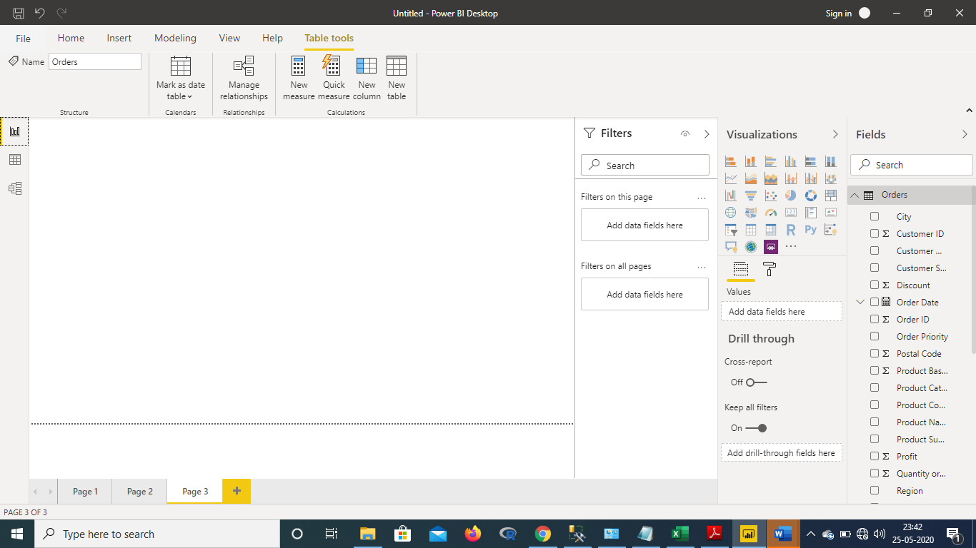

**Data View** – Data view helps you inspect, explore, and understand data in your Power BI Desktop model.

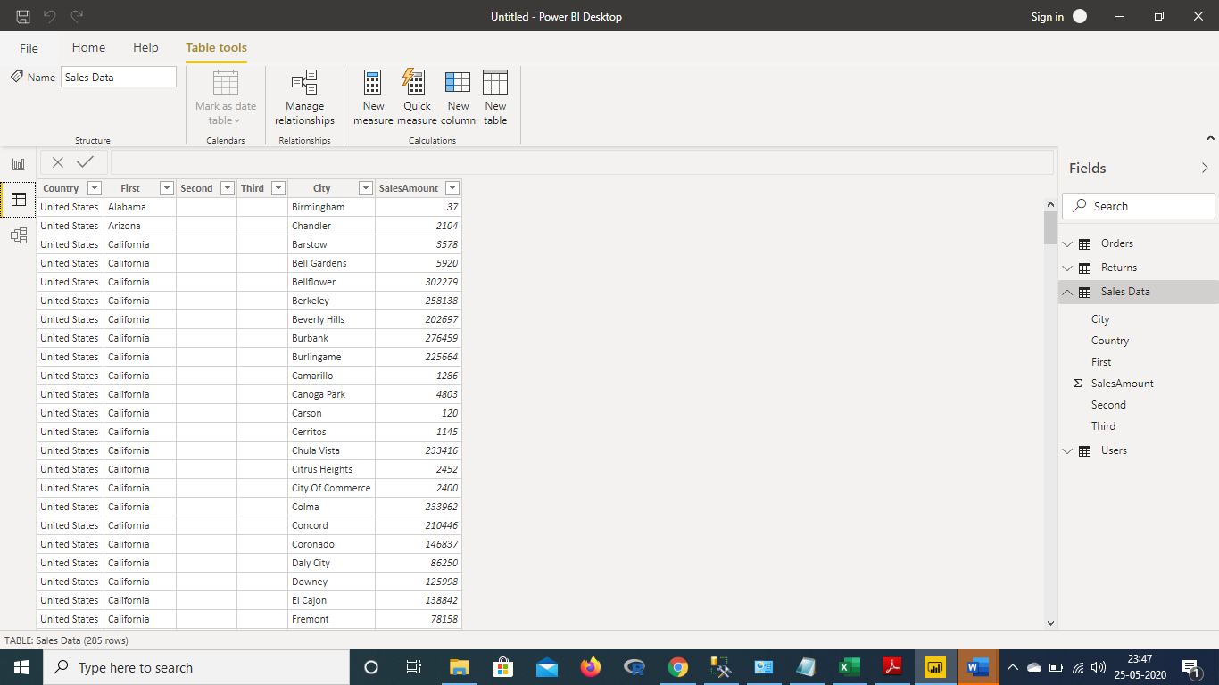

Model View – Work with Model view in Power BI Desktop Model view shows all of the tables, columns, and relationships in your model

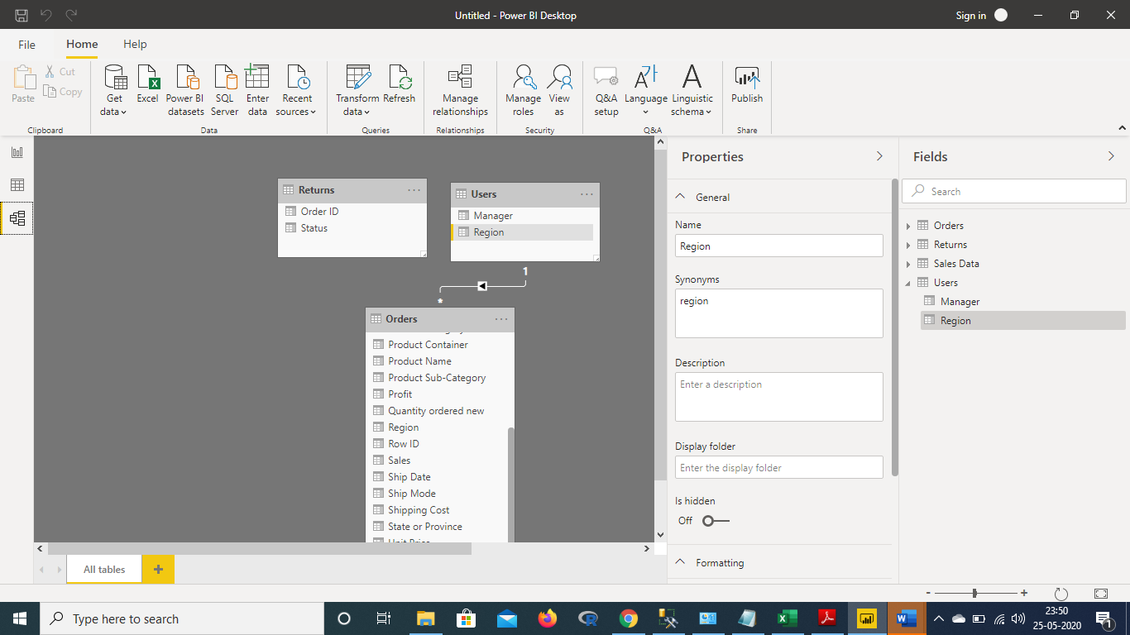

Power Query Editor – Power Query is made available in Power BI Desktop through Power Query Editor. To launch Power Query Editor, select Edit Queries from the Home tab of Power BI Desktop

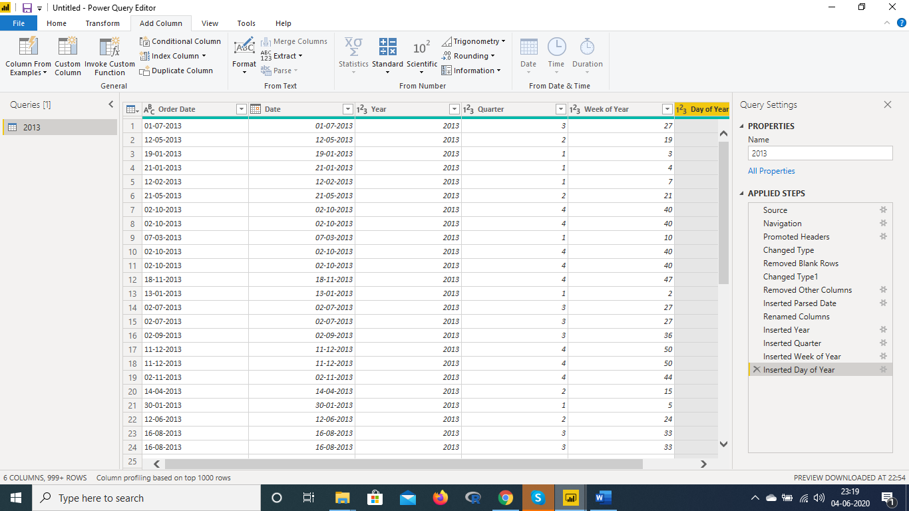

Advance Editor : To launch the advanced editor, select View from the ribbon, then select Advanced Editor. A window appears, showing the existing query code. You can directly edit the code in the Advanced Editor window .

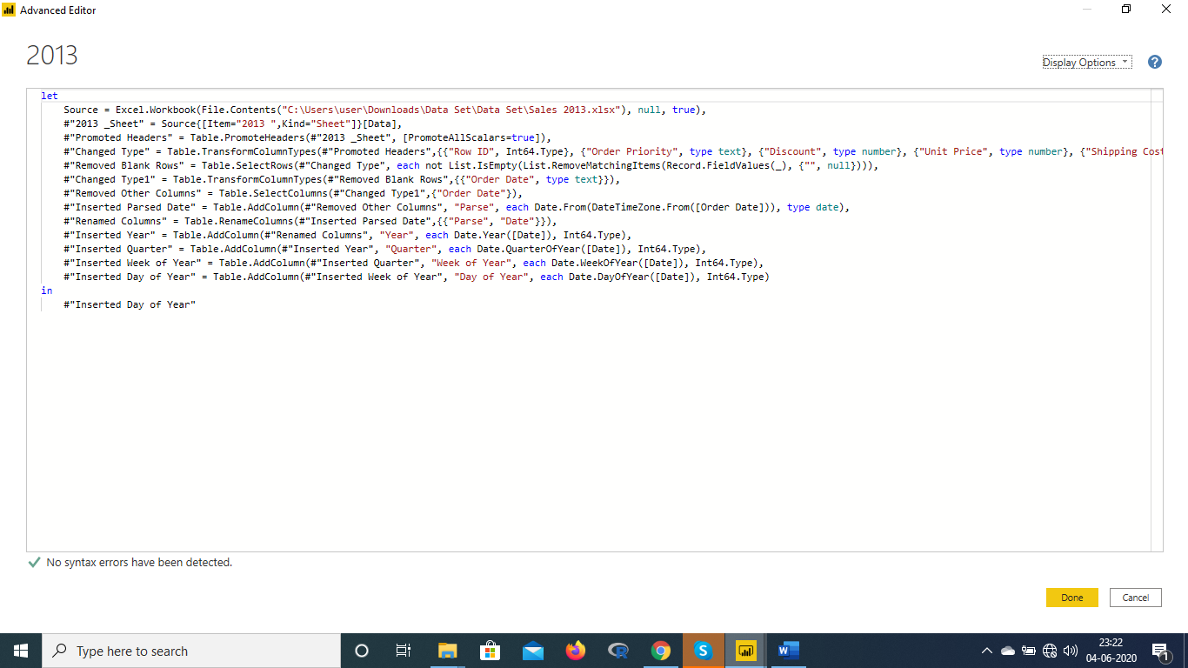

3 Prepare a document with details of the following along with their price –

Power BI Desktop – This is a free version available to any single user and includes data cleaning and preparation, custom visualizations and the ability to publish to the Power BI service.

Power BI Pro: The Pro plan costs $9.99/user/month.

Power BI Premium- The Pro plan costs $4,995/user/month.